COMFORTER MAKWEYA

CHALLENGE 3

1. Explanation of how websites work and hosting is done:

- The browser goes to the DNS server, and finds the real address of the server that the website lives on (you find the address of the shop).
- The browser sends an HTTP request message to the server, asking it to send a copy of the website to the client (you go to the shop and order your goods). This message, and all other data sent between the client and the server, is sent across your internet connection using TCP/IP.

- If the server approves the client's request, the server sends the client a "200 OK" message, which means "Of course you can look at that website! Here it is", and then starts sending the website's files to the browser as a series of small chunks called data packets (the shop gives you your goods, and you bring them back to your house).

- The browser assembles the small chunks into a complete web page and displays it to you(the goods arrive at your door — new shiny stuff, awesome!).

  - So at this stage we have a domain name and we also have domain name servers making sure that our domain name is properly routing visitors to our website when they type in the domain name.Our actual website is just a bunch of files. HTML files, CSS files (stylesheets), images and photos, etc. All of these files need to be in a folder on a computer that is connected to the Internet. That computer is usually called a “server” because it serves up our website files when people come to visit. When you pay a company to put your files on their web server, you’re buying hosting. They are hosting your website on their servers.So now that we have it all setup, here’s what happens when you visit the new website.You type the domain name into your web browser. The DNS makes sure you get connected to the right computer. And that computer or server has your website files hosted on it. Let’s look at a diagram to make sure this all clicks in your head.
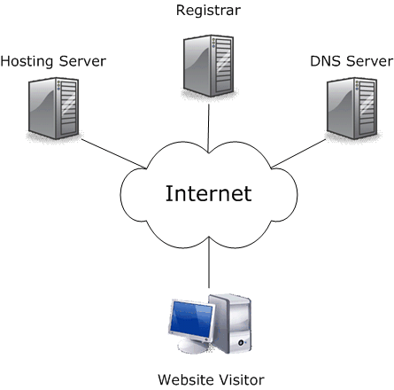
  - This diagram gives you the idea of it all.
2. I chose to write on DATABASE TESTING -

Database testing is known as data validation and integrity testing or back-end testing.
UI testing or front-end testing is also called Application testing or GUI testing.
Database testing involves testing of back-end components, which are not visible to users.
This includes database components and DBMS systems such as My SQL, Oracle.
UI testing involves checking functionalities of an application and its components like forms, graphs, menus, reports, etc.
These components are created using front-end development tools like VB.net, C#, Delphi, etc.
Database testing involves checking stored procedures, views, schemas in database, tables, indexes, keys, triggers, data validations and data consistence check.
UI testing involves checking the functionality of application, buttons, forms and fields, calendar and images, navigation from one page to other, and the overall functionality of the application.
To perform DB testing, a tester needs a thorough knowledge of database concept − like procedures and functions, views, indexes, keys and good hands-on SQL.
To perform UI testing, a tester needs a good understanding of business requirements, application functional knowledge, coding, etc.
Data comes from multiple heterogeneous data sources over web applications, Intranet applications and various other applications.
Data is entered manually into applications. It involves functional testing of front-end application performance of the database.

Database Testing – Types
Based on the function and structure of a database, DB testing can be categorized into three categories −
- Structural Database Testing − It deals with table and column testing, schema testing, stored procedures and views testing, checking triggers, etc.
- Functional Testing − It involves checking functionality of database from user point of view. Most common type of Functional testing are White box and black box testing.
- Non-functional Testing − It involves load-testing, risk testing in database, stress testing, minimum system requirements, and deals with the performance of the database.

